1.what is a program?
→ A program is a set of instructions that a computer or other device follows to perform a specific task.

2. Write a simple "Hello World" program in two different programming languages of your choice. Compare the structure and syntax.
→ A simple “hello world” program of two different programming languages:
Python:
print("Hello, World!")
C:
#include <stdio.h>
int main() {
printf("Hello, World!\n");
return 0;
}
Structure and syntax :
- Structure:
  - Python: The Python program is a single line of code. It directly executes the print() function to display the message.
  - C: The C program has a more structured format. It requires including a header file (stdio.h) for input/output functions, and the core logic resides within the main() function, which serves as the program's entry point. The return 0; statement indicates successful program execution.
- Syntax:
  - Python: Python's syntax is concise and high-level. It uses the built-in print() function to output text, and no semicolons are required at the end of statements.
C: C's syntax is more explicit and low-level. It uses the printf() function (from stdio.h) for output, requires semicolons to terminate statements, and uses curly braces {} to define code blocks, such as the body of the main() function. The \n character is used to insert a new lime.

3: explain in your own words what a program is and how it functions.
→A program is a set of instructions that you give to a computer to make it do something useful(like opening a game,or showing a website).

4.What is programming?
→ Programming is the process of writing instructions for a computer to perform a specific task, like creating software or apps.

5: What are the key steps involved in the programming process?
->key steps
Understand the problem
a. Plan the solution
b. Write clean code
c. Test thoroughly
d. Debug and fix
e. Deploy to users
f. Maintain and improve.

6. Types of programming language.
→ C , C++ , HTML , CSS ,JS , PYTHON .

7. What are the main differences between high-level and low-level programming languages?
→ High level languages prioritize programmer productivity and portability. They let you write complex programs quickly without worrying about the underlying hardware.
Low level languages prioritize performance and fine-grained control.They are essential when every CPU cycle or byte of memory matters (e.g. kernels and real time system).

8.World Wide Web & How the Internet Works.
→The Internet is a global network of interconnected computers that allows devices to communicate and share data using protocols like TCP/IP. The World Wide Web (WWW) is a service that runs on the Internet and provides access to websites and web pages through web browsers. While the Internet is the physical network infrastructure, the Web is a collection of linked documents accessed using HTTP/HTTPS. In simple terms, the Internet is the network, and the Web is one of the services available on that network.

9.Research and create a diagram of how data is transmitted from a client to a server over the internet.
→
→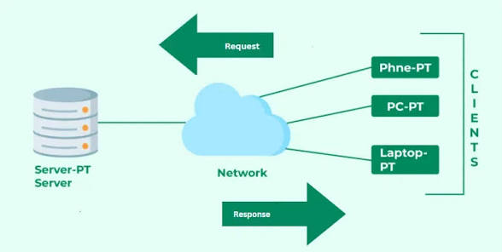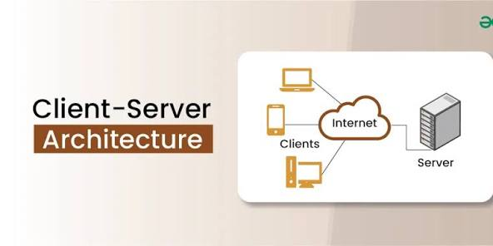
Data is transmitted from a client to a server over the internet by first breaking the data into small, addressed packets. These packets travel across the network, potentially taking different paths, to reach the server. The server receives all the packets, and a protocol like TCP reassembles them into the original data to be processed.
1. Client-Side Processing
- Packetization: A client application creates data and divides it into smaller pieces called packets.
- Encapsulation: The client adds headers to each packet. The header contains information such as the source and destination IP addresses, packet sequence number, and error-checking codes.
2. Transmission and Routing
- Dynamic Path Selection: The packets are sent out into the network, where they are routed through various devices like routers.
- Dynamic Path Selection: The internet is a robust network, and if one path is blocked, packets will be routed along a different path to their destination.
3. Server-Side Processing
- Packet Reception: The server receives the individual packets as they arrive.
- Packet Reconstruction: The server uses the sequence numbers in the packet headers to reassemble the packets in the correct order, rebuilding the original data.
- Processing: The server processes the reassembled data (e.g., a web request, file upload, etc.) and sends back a response to the client.

10.Describe the roles of the client and server in web communication. Network Layers on Client and Server.
→ In web communication ( primarily HTTP/HTTPS protocol ) the client and server have clearly defined ,asymmetric roles :
a. The client always initiates and asks for something .
b. The server waits, processes , and answers.
c. Every layer (application →transport →link) is used on both sides .but the direction of initiation and listening differs, especially at the transport and application layers.

11.Network Layers on Client and Server.
→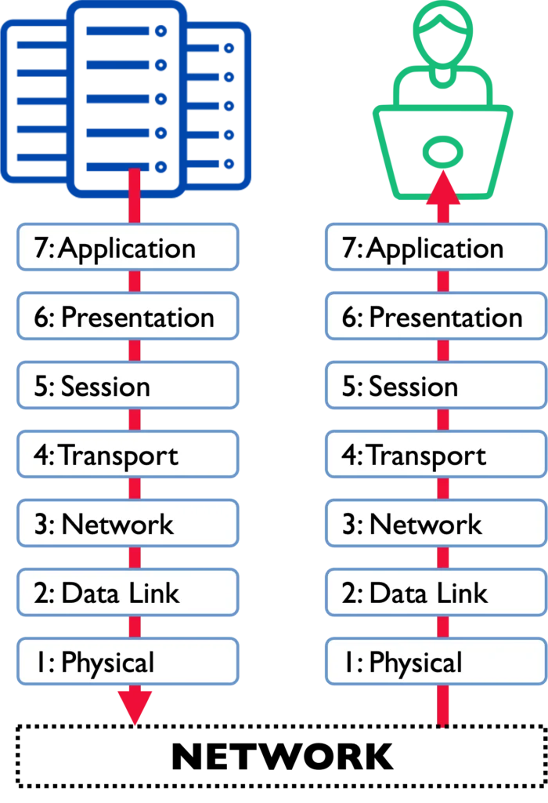

12.Design a simple HTTP client-server communication in any language.
→
- Server:
  - Creates a socket object using socket.AF_INET (IPv4) and socket.SOCK_STREAM (TCP).
  - Binds the socket to a specific HOST and PORT.
  - listen() puts the server into listening mode for incoming connections.
  - accept() blocks until a client connects, then returns a new socket object (conn) for that connection and the client's address (addr).
  - Receives data from the client using conn.recv(), decodes it, and prints the raw HTTP request.
  - Constructs a basic HTTP response with a 200 OK status and a plain text body.
  - Sends the encoded response back to the client using conn.sendall().
- Client:
  - Uses the requests library, which simplifies making HTTP requests.
  - Sends a GET request to the SERVER_URL.
  - Prints the status_code and the text (body) of the server's response.
  - Includes basic error handling for connection issues.
To run this example:
- Save the server code as server.py and the client code as client.py.
- Open two separate terminal windows.
- In one terminal, run the server: python server.py
- In the other terminal, run the client: python client.py
The client will send a request, and the server will respond, demonstrating a basic HTTP client-server interaction.

13.Explain the function of the TCP/IP model and its layers. Client and Servers.
→ The TCP/IP model (also called the Internet protocol suite) defines how data is packaged,addressed,transmitted,routed,and received across networks.
> This model has 4 layers :
1.link layer ( network interface/network access layer)
2.internet layer ( network layer )
3.transport layer
4.application layer
>the TCP/IP is a 4 layer practical model :
Application→transport →internet→link.

14. Explain Client Server Communication.
→The client server model is the most common way computers and applications talk to each other over network ( like the internet ). It divides the work into two roles:
→Client : the requester ( usually your browser,mobile app or any program that needs something).
→server: the provider ( a powerful computer that stores data , runs applications, or hosts websites and waits for requests ).

15.Types of Internet Connections .
→
-Digital subscriber line (DSL)
- Cable internet
- Fiber optic
- Satellite Internet
- Wireless
- Broadband over power lines (BPL)

16.Research different types of internet connections (e.g., broadband, fiber, satellite)and list their pros and cons.
→
Internet connections like fiber are the fastest and most reliable but are not universally available, while cable is a widely available option that can experience slower speeds during peak hours. DSL uses phone lines, making it accessible but generally slower and more distant-dependent, whereas satellite provides the widest availability, especially in rural areas, but suffers from higher latency and susceptibility to weather interference.
Connection Type | Pros | Cons
Fiber Optic | - Fastest speeds (up to 10 Gbps)  - Most reliable and secure connection  - Good for high-demand activities like gaming, streaming, and large downloads | - Limited availability; not available everywhere  - Can be expensive to install
Cable | - Widely available, uses existing infrastructure  - Faster speeds than DSL (up to 1 Gbps)  - Good for streaming and business use | - Shared bandwidth means speeds can slow down during peak hours  - Less reliable than fiber
DSL | - Uses existing telephone lines, making it widely accessible  - Relatively affordable | - Speed is dependent on distance from the central hub  - Slower than cable or fiber
Satellite | - Available almost anywhere, making it ideal for rural/remote areas  - Wireless connection | - Highest latency, causing lag in real-time applications like gaming and video calls  - Vulnerable to weather delays (rain, snow)  - Can be more expensive and have data caps
4G/5G Wireless | - High speeds (up to 10 Gbps)  - Mobile and flexible  - Can be a good backup for broadband | - Highly dependent on signal strength and location  - Can be expensive for heavy data users  - Not ideal for large downloads or streaming without a stable signal

17.How does broadband differ from fiber-optic internet?
→ Broadband is a general term for any high speed internet connection ( faster than old dial up ). It includes several technologies:
→DSL (over copper phone lines)
→cable ( over TV coaxial cables )
→fiber optic
→fixed wireless
→satellite
Fibre optic internet is a specific type of broadband that uses thin glass or plastic fibres to transmit data as pulses of light.

18.Simulate HTTP and FTP requests using command line tools (e.g., curl).

→ Simulating HTTP Requests with curl

1.1 HTTP GET Request
Used to retrieve information from a server.
curl http://example.com
Show response headers as well:
curl -i http://example.com

1.2 HTTP POST Request
Used to send data to a server.
Send form data:
curl -X POST -d "username=test&password=1234" http://example.com/login
Send JSON data:
curl -X POST \
-H "Content-Type: application/json" \
-d '{"name":"John","age":20}' \
http://example.com/api/user
1.3 Custom Headers
Simulate an HTTP request with extra headers (e.g., authentication):
curl -H "Authorization: Bearer TOKEN123" \
-H "Accept: application/json" \
http://example.com/api/data
1.4 Downloading a File via HTTP
curl -O http://example.com/file.zip
2. Simulating FTP Requests with curl

2.1 FTP Download (Anonymous)
curl -O ftp://ftp.example.com/pub/file.txt
2.2 FTP Download with Username and Password
curl -u user:pass -O ftp://ftp.example.com/files/report.pdf
2.3 Uploading a File to an FTP Server
curl -T upload.txt \
-u user:pass \
ftp://ftp.example.com/uploads/
2.4 Listing FTP Directory Contents
curl -u user:pass ftp://ftp.example.com/
Conclusion
Using curl, we can easily simulate both HTTP and FTP operations directly from the command line. This includes sending GET and POST requests, adding headers, downloading files, uploading files, and authenticating with remote servers. This makes curl an essential tool for network testing and protocol simulation.

19.What are the differences between HTTP and HTTPS protocols?
→ HTTP -
- Unsecured ;data is sent in plain text and is vulnerable to interception.
- No encryption
- Uses port 80 by default
- No authentication.
HTTPS -
- Secure;data is encrypted and protected by a TLS/SSL certificate.
- Uses encryption to scramble data,making it unreadable to unauthorised users.
- Uses port 443 by default.
- Provides authentication.

20. Identify and explain three common application security vulnerabilities. Suggest possible solutions.
→Three common application security vulnerabilities are Injection, Broken Authentication, and Security Misconfiguration. Injection flaws allow attackers to insert malicious code, broken authentication weaknesses permit unauthorized access, and security misconfigurations result from insecure default settings or poor deployment. Solutions include proper input validation for injection, multi-factor authentication and strong session management for broken authentication, and comprehensive hardening and patching for misconfigurations.
1. Injection
- Vulnerability: This occurs when untrusted data is sent to an interpreter as part of a command or query, such as a SQL injection or cross-site scripting (XSS). Attackers can use this to execute arbitrary commands, read or modify data in a database, or run scripts in the user's browser.
- Solution:
  - Input Validation: Use a "deny list" or "allow list" to validate and sanitize all user input before processing it.
  - Parameterized Queries: Use prepared statements or parameterized queries instead of dynamically constructing SQL queries to prevent SQL injection.
  - Output Encoding: Properly encode all data before it is displayed in a web browser to prevent XSS.
2. Broken Authentication
- Vulnerability: This category includes flaws that allow attackers to compromise user credentials or session management. Common issues include weak password policies, predictable session IDs, improper password hashing and salting, and allowing users to stay logged in indefinitely.
- Solution:
  - Multi-Factor Authentication (MFA): Implement MFA to add an extra layer of security beyond just a password.
  - Strong Session Management: Use strong, randomly generated session IDs and ensure sessions have proper timeouts and are invalidated on logout.
  - Secure Credential Storage: Store passwords securely using modern, strong, one-way hashing and salting techniques.
3. Security Misconfiguration
- Vulnerability: This vulnerability arises from insecure default settings or incomplete configurations across the application, framework, server, or database. Examples include leaving default administrative passwords, enabling unnecessary features, or exposing sensitive error messages.
- Solution:
  - Hardening: Remove or disable all unnecessary features and access.
  - Patching: Keep all software, frameworks, and dependencies up to date with the latest security patches.
  - Secure Defaults: Do not use default credentials and ensure all security settings are reviewed and hardened during deployment.
21.What is the role of encryption in securing applications?
→encryption secures application by transforming data into an unreadable format,protecting it from unauthorised access and cyber threats while its being stored (data at rest ) or transmitted (data in transit).
22.Software Applications and Its Types .
→Types of application software
Productivity Software
Word Processors
Spreadsheet Software:
Presentation Software:
Multimedia Software
Graphics and Design Software
Web Browsers:
Communication Software:
Utility Software

23.Identify and classify 5 applications you use daily as either system software or application software.
→
Below are 5 applications i use daily :
1. Windows 11 – System software It’s literally the operating system on laptop, without it nothing runs.
2.Google Chrome – Application software I open it every day to browse, watch YouTube, and do assignments.
3.Microsoft Edge (the antivirus one) – System software Windows Defender runs in the background all the time to protect my PC.
4.WhatsApp Desktop – Application software I’m always chatting with my friends and group members for projects.
5.VLC Media Player – Application software Use it daily to watch downloaded lectures and movies.

24.What is the difference between system software and application software?
→

 | System software | Application software
 | To manage hardware and provide a platform for other software | To perform specific tasks for the end-user
 | Runs in the background; minimal direct user interaction | Users interact with it directly to achieve a goal
 | Required for the computer to function | Optional; can be installed or removed based on user need
 | Often pre-installed with the computer | Installed by the user as needed

25..Design a basic three-tier software architecture diagram for a web application.
→
→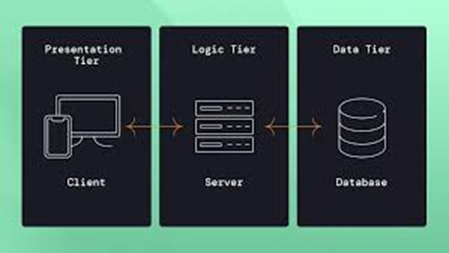

26. Software architecture.
→Software architecture is the high-level blueprint for a software system that defines its structure, components, and the rules governing their interactions.

27. What is the significance of modularity in software architecture?
→ Modularity is significant in software architecture because it breaks down a system into smaller, independent components, which enhances flexibility, scalability, and maintainability. This approach allows for parallel development, easier testing and debugging, and promotes code reusability. By isolating functionalities into modules, developers can make changes to one part without affecting the entire system.

28.Layers Software architecture .
→ – Presentation layer
– Application layer
– Business layer
– Persistence layer
– Database layer

29.Create a case study on the functionality of the presentation, business logic, and data access layers of a given software system.
→
This case study examines the functionality of the presentation, business logic, and data access layers within an online bookstore application.
1. Presentation Layer (UI Layer)
- Functionality: This layer is responsible for all user interaction and visual representation. It includes elements like the website's layout, navigation menus, product display pages, shopping cart interface, and user account management forms. It captures user input (e.g., search queries, adding items to the cart, checkout details) and displays information retrieved from the business logic layer.
- Example Interaction: A user searches for "fiction novels." The presentation layer captures this search query and sends it to the business logic layer. Upon receiving a list of matching books, the presentation layer renders these books in a visually appealing format, including titles, authors, prices, and cover images.
2. Business Logic Layer (BLL)
- Functionality: The BLL encapsulates the core rules and operations of the online bookstore. It acts as an intermediary between the presentation and data access layers, ensuring data integrity and enforcing business policies. This includes processing orders, managing inventory, applying discounts, validating user input, and implementing search algorithms.
- Example Interaction: When a user adds a book to their cart, the presentation layer sends this request to the BLL. The BLL then checks inventory availability through the data access layer, applies any relevant discounts, calculates the subtotal, and updates the shopping cart's state. When a user proceeds to checkout, the BLL orchestrates the order placement, including payment processing and updating inventory levels.
3. Data Access Layer (DAL)
- Functionality: The DAL provides an abstraction layer for interacting with the underlying data storage (e.g., a relational database like SQL Server or a NoSQL database). It handles all data persistence operations, including creating, reading, updating, and deleting (CRUD) data related to books, users, orders, and inventory. It shields the BLL from the complexities of specific database technologies.
- Example Interaction: When the BLL needs to check the availability of a book, it calls a method in the DAL, such as GetBookInventory(bookId). The DAL then executes the appropriate database query (e.g., SELECT QuantityInStock FROM Books WHERE BookID = bookId) and returns the result to the BLL. Similarly, when an order is placed, the BLL instructs the DAL to save the order details and update the inventory for the purchased books.
Inter-Layer Communication:
- The Presentation Layer communicates with the Business Logic Layer by sending user requests and receiving data to display.
- The Business Logic Layer communicates with the Data Access Layer by requesting data retrieval or storage operations and receiving processed data.
- The Data Access Layer interacts directly with the database, performing operations based on requests from the BLL and returning results.
This layered architecture promotes modularity, maintainability, and scalability by separating concerns and allowing independent development and modification of each layer.

30.Why are layers important in software architecture?
→Layers are important in software architecture because they create separation of concerns, which leads to more maintainable, testable, and scalable systems. By dividing a complex application into distinct layers with specific responsibilities (like presentation, business logic, and data access), developers can work on parts independently, isolate issues for easier debugging, and scale individual layers based on their specific needs.

31.Software Environments .
→A software environment is the collection of hardware and software components needed to develop, test, and run applications

32. Explore different types of software environments (development, testing, production).Set up a basic environment in a virtual machine.
→
Different Types of Software Environments
Software development typically involves distinct environments tailored for specific stages of the lifecycle:
- Development Environment: This is the workspace where developers write, debug, and test code locally. It's characterized by flexibility and often includes tools like Integrated Development Environments (IDEs), version control systems, and local databases. Developers have full control and can experiment without impacting others.
- Testing Environment (QA/Staging): This environment is designed for quality assurance and testing activities. It closely mirrors the production environment in terms of hardware, software, and data to identify bugs and performance issues before deployment. Various types of testing, including functional, performance, and security testing, are conducted here. A "staging" environment is a specific type of testing environment that aims to be a near-identical replica of production for final validation.
- Production Environment: This is the live environment where the software is deployed and accessible to end-users. Stability, security, and performance are paramount in this environment. Changes are implemented with extreme caution to minimize downtime and avoid disrupting user experience.
Setting Up a Basic Environment in a Virtual Machine
To set up a basic environment in a virtual machine (VM), follow these general steps:
- Install Virtualization Software: Choose and install a virtualization software like VirtualBox, VMware Workstation Player, or Hyper-V on your host machine.
- Create a New Virtual Machine:
  - Open your virtualization software and select the option to create a new VM.
  - Specify the operating system (e.g., Ubuntu, Windows Server) you intend to install within the VM.
  - Allocate resources such as RAM, CPU cores, and hard disk space for the VM. Ensure sufficient resources for your intended use (e.g., development tools, server applications).
  - Create a virtual hard disk file for the VM.
- Install the Operating System:
  - Mount the ISO image of your chosen operating system to the VM's virtual CD/DVD drive.
  - Start the VM and follow the on-screen instructions to install the operating system as you would on a physical machine.
- Install Guest Additions (Recommended): After the OS installation, install the "Guest Additions" provided by your virtualization software. This enhances integration between the host and guest OS, enabling features like shared folders, seamless mouse integration, and better display resolution.
- Configure the Environment:
  - Development: Install necessary development tools (IDEs, compilers, language runtimes like Python, Java, Node.js), version control clients (Git), and any required databases (e.g., MySQL, PostgreSQL).
  - Testing: Install testing frameworks, tools for performance or security testing, and potentially a web server if testing a web application.
  - Networking: Configure network settings within the VM (e.g., bridged adapter for network access, host-only adapter for isolated communication).

33. Explain the importance of a development environment in software production.
→A development environment (dev environment) is crucial in software production as it provides a safe, isolated, and feature-rich workspace for developers to write, test, and debug code before it reaches end-users [1]. It acts as a controlled testing ground that mirrors the production environment's settings, ensuring consistency and preventing errors in the live system [1].
Key Importance of a Development Environment:
- Isolation and Safety: The dev environment is separate from the live production system, so any mistakes, bugs, or crashes during the development phase do not impact the application's availability or stability for existing users [1].
- Rapid Iteration and Experimentation: It allows developers to quickly test new features, experiment with different approaches, and debug issues without the pressure of breaking the live application. This fosters innovation and faster problem-solving [1].
- Controlled Testing Ground: By closely mirroring the production environment (e.g., using similar operating systems, databases, and configurations), the dev environment helps identify potential compatibility issues early in the process. This practice, often referred to as "staging" or pre-production, ensures the software behaves predictably when deployed live [1].
- Collaboration and Version Control: Development environments facilitate collaboration among teams. Through integration with version control systems (like Git), multiple developers can work on different features simultaneously without interfering with each other's work [1].
- Access to Development Tools: It provides necessary tools for efficient coding, such as Integrated Development Environments (IDEs), debuggers, performance monitors, and testing frameworks. These tools streamline the coding process and enhance code quality [1].
- Risk Mitigation: By catching bugs and configuration errors early, a dev environment significantly reduces the risk of costly downtime, data corruption, or negative user experiences that could occur if testing happened directly on the production server [1].
In essence, a development environment is a fundamental component of the software development lifecycle, enabling a structured, safe, and efficient workflow that is essential for producing high-quality, reliable software [1].

34.source code.
→ Source code is a set of instructions written in a human-readable programming language, created by programmers to define how a computer program functions.

35. What is the difference between source code and machine code?
→ The main difference between source code and machine code is how close they are to human understanding. Source code is the version of a program that humans write using programming languages like Python, Java, or C. It uses words, symbols, and structures that are meant to be readable so programmers can understand and modify it.
Machine code, on the other hand, is the low-level set of instructions that the computer actually runs. It’s made up of numbers (binary) that the computer’s processor understands directly. Humans usually don’t write machine code manually because it’s difficult to read and work with.
In simple terms:
- Source code is for people.
- Machine code is for computers.

36.Github and Introductions.
→ GitHub is a web-based platform that provides hosting for software development and version control using Git. It facilitates collaboration among developers and offers tools for managing code, tracking changes, and coordinating projects.

37.: Why is version control important in software development?
→ Version control is important in software development because it keeps track of changes to code over time. It lets developers see who changed what, when they changed it, and why. This is really helpful when something breaks, because you can go back to an earlier version that worked.
It also makes teamwork easier. Multiple people can work on the same project without accidentally overwriting each other’s work. Version control systems help merge everyone’s changes together and highlight any conflicts that need to be fixed.
Overall, it helps keep projects organized, reduces mistakes, and makes it possible to manage even large and complex codebases in a safer way.

38. What are the benefits of using Github for students?
→ Using GitHub has a lot of benefits for students. One big advantage is that it helps you organize your projects and keep all your code backed up in one place. If you mess something up, you can go back to an earlier version instead of restarting the whole thing.
GitHub gives students a professional tool for learning good coding habits, working in teams, and showing off their work.

39.Types of Software.
→ 1.Application software. 2.System software. 3.driver software 4.Middleware 5.programming software.

40.Create a list of software you use regularly and classify them into the following categories: system, application, and utility software.
→ System Software:
- Windows 11 (my laptop’s operating system)
- Android (on my phone)
Application Software:
- Microsoft Word (for assignments)
- Google Chrome (browsing)
- Spotify (listening to music)
- Zoom (online classes)
- Netflix (streaming)
Utility Software:
- Windows Defender (antivirus)
- WinRAR (file compression)
- CCleaner (clean-up and maintenance)

41. What are the differences between open-source and proprietary software?
→ Open-source software and proprietary software mainly differ in how they are shared and who controls them. Open-source software lets users see and modify the source code. That means anyone can study how it works, fix issues, or even change it to suit their needs. It’s usually free, and it’s built by a community of developers who contribute to the project.
Proprietary software, on the other hand, is closed off. The company that made it keeps the source code private, and users are only allowed to use it under certain rules or licenses. You can’t change the code, and you often have to pay for it. Updates and improvements also depend completely on the company.
In short:
- Open-source = visible code, more freedom, often community-driven.
- Proprietary = closed code, controlled by a company, usually paid.

43.How does GIT improve collaboration in a software development team?
GIT significantly enhances collaboration in software development teams through its distributed nature and robust features.
1. Distributed Version Control.
2. Branching and Merging.
3. Conflict Resolution.
4. Code Review and Feedback
5. Clear History and Accountability.
6. Flexibility in Workflow.

44. Write a report on the various types of application software and how they improve productivity.
→ Application software refers to the programs people use to perform specific tasks on a computer or mobile device. These tools are designed to make work easier, faster, and more organized. There are several types of application software, and each one helps improve productivity in different ways.
1. Word processing software - like Microsoft Word or Google Docs. These programs make writing and editing documents much easier than doing everything by hand. They offer features such as spell check, formatting tools, and templates, which save time and help users create clean, professional-looking work.
2. Spreadsheet software - such as Microsoft Excel. Spreadsheets help with calculations, organizing data, and making charts. This is especially useful for budgeting, analyzing information, or keeping records. Tasks that would take a long time to do manually can be completed quickly with formulas and built-in functions.
3. Presentation software - like PowerPoint or Google Slides, also plays a big role in productivity. These programs help users create visual presentations for school, work, or meetings. They make it simple to combine text, images, and graphics, allowing ideas to be communicated more clearly.
There are also database management systems, which help store and manage large amounts of information. These are useful for businesses, schools, and organizations that need to keep their records organized and easy to search.
In addition, communication software—such as email apps, messaging tools, and video conferencing platforms—helps people stay connected. Programs like Gmail, WhatsApp, and Zoom make it easier to share information quickly and work with others even from a distance.
Lastly, media editing software, like photo or video editors, improves productivity by making it possible to create and edit content efficiently. This type of software is used for school projects, marketing, and creative work.

45.: What is the role of application software in businesses?
→ Application software plays an important role in businesses because it helps make everyday tasks easier and more organized. Different types of software are used for different purposes. For example, businesses use word processors and spreadsheet programs to create documents, reports, and budgets. These tools help save time and reduce errors.
Companies also rely on communication software like email, messaging apps, and video meeting tools to stay connected with employees and customers. This makes it easier to share information quickly and work together, even when people aren’t in the same place.
Many businesses use database or management software to keep track of customer information, sales records, and inventory. This helps them stay organized and make better decisions based on accurate data.
Overall, application software improves productivity, helps with teamwork, and allows businesses to run their operations more smoothly and efficiently.

46. Create a flowchart representing the Software Development Life Cycle (SDLC).
→ 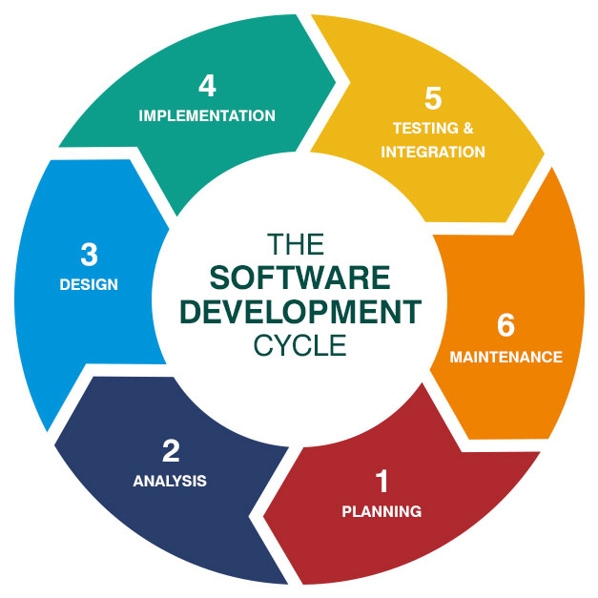

47. What are the main stages of the software development process?
→ the main stages of the software development process:
1. Planning
- This is where the goals of the project are discussed and the basic idea of the software is decided.
2. Requirements Analysis
- The team gathers information about what the users need and what the software must be able to do.
3. Design
- The structure of the software is planned out, including how the system will look and how different parts will work together.
4. Development (Coding)
- Programmers write the actual code to build the software based on the design.
5. Testing
- The software is checked for errors, bugs, and any issues to make sure it works correctly.
6. Deployment
- The completed software is released to users so they can start using it.
7. Maintenance
- After release, updates, fixes, and improvements are made to keep the software running smoothly.

48.Software requirement.
→ Software requirements describe a system's functionality, performance, and constraints, acting as a blueprint for what the software must do and how it should behave. This includes both functional requirements (what the system does) and non-functional requirements (how well the system performs, like security and usability).

49. Write a requirement specification for a simple library management system.
→ 1. LMS : library management system.
2. User : member using the library.
3. Librarian: administrator of the system.
4.Issue : borrow a book.
5. Return : give back a borrowed book.

50. Why is the requirement analysis phase critical in software development?
→ The requirements analysis phase is critical in software development because it is the foundation on which the entire project is built. Getting it wrong (or skipping it) is the single most common reason why software projects fail, run over budget, or deliver something the users don’t actually want. Here are the key reasons why this phase is non-negotiable:
1. Prevents building the wrong product.
2. Dramatically reduces costly rework.
3. Establishes a clear scope and shared understanding.
4. Enables accurate estimation and planning.
5. Identifies risks and non-functional requirements early.
6. Improves stakeholder buy-in and reduces conflict.

51. Software analysis .
→ Software analysis is a critical phase of the software development lifecycle that involves understanding and documenting the requirements for a new system and designing a solution to meet those needs.

52.Perform a functional analysis for an online shopping system.
→ 1.Guest. 2. Registered customer. 3.Admin. 4.seller. 5.payment gateway 6.Shipping provider 7.search or recommendation engine.

53.What is the role of software analysis in the development process? → Software analysis plays a critical early role in the software development process. Its main purpose is to understand what needs to be built before deciding how to build it. Here’s what it typically involves:
Key Roles of Software Analysis

1. Requirements Gathering

2. Problem Understanding

3. Feasibility Assessment .

4. Requirements Specification

5. Reducing Risks .

6. Foundation for Design and Development.

54.System design
→
System design is the process of planning and defining the architecture, components, interfaces, and data of a system to meet specific requirements.

55. What are the key elements of system design?
→ The key elements of system design can be categorized into architectural components and design principles. The goal of system design is to create a blueprint that outlines how different parts of a software system will work together to meet specific requirements like scalability, reliability, and performance.

ARCHITECTURAL COMPONENTS - These are the building blocks that make up a large-scale system.
DESIGN PRINCIPLES - These are the non-functional requirements and considerations that guide the architectural choices.

56. Software testing . → Software testing is a critical process within the software development lifecycle that involves evaluating and verifying a software application to ensure it functions correctly, meets specified requirements, and is free of defects.

57. Why is software testing important? → Software testing is critically important because it saves money, mitigates risk, and ensures the quality, security, and reliability of the final product, which directly impacts customer satisfaction and a company's reputation.It's an essential part of the Software Development Life Cycle (SDLC) that verifies the software works as intended and meets the needs of the end-users.

58. Maintenance.
→In programming, maintenance is the process of modifying a software program after it has been released to fix errors, improve performance, add new features, and adapt to new or changing environments.

59.What types of software maintenance are there?
→ The four universally recognized categories of software maintenance are: Corrective, Adaptive, Perfective, and Preventive.
These categories cover all post-deployment activities performed to keep software operational, relevant, and efficient over its entire lifecycle.
1. Corrective Maintenance - This is the most common and often reactive type of maintenance. It is performed to identify, isolate, and rectify errors, faults, and bugs that users or internal testers have discovered.

2. Adaptive Maintenance- This type is performed to modify the software to cope with changes in its external environment. The core functionality of the application doesn't change, but its operational context does.

3. Perfective Maintenance - This involves making enhancements, improvements, and refinements to existing software functionality based on user feedback and evolving requirements. It is about making the software better, not just fixing it.

4. Preventive Maintenance - This is a proactive approach to look for potential problems (latent faults) in the code and fix them before they manifest as actual errors. The goal is to improve the longevity and stability of the system.

60.developement.
→In programming, development is the systematic process of conceiving, designing, building, and maintaining computer programs and applications.

61.What are the key differences between web and desktop applications?
→
Feature | Web Application | Desktop Application
Installation | Not Required. Accessed via a web browser (e.g., Chrome, Safari). | Required. Must be downloaded and installed on a local device.
Internet | Required for full functionality, as the application logic and data reside on a remote server. | Optional/Not Required. Works offline, as the logic and data are stored locally.
Accessibility | Cross-Platform/Anywhere. Accessible from any device (PC, Mac, mobile) with a browser and internet connection. | Platform-Dependent/Limited. Accessible only on the specific device/OS (Windows, macOS, Linux) it was installed on.
Updates | Automatic/Centralized. Updates are made on the server and instantly available to all users. | Manual/User-Driven. Users must download and install updates individually.
Examples | Gmail, Google Docs, Facebook, Salesforce | Microsoft Word, Adobe Photoshop, VLC Media Player, most high-end video games

62. Web application.
→ Web application refers to the process of designing, building, and maintaining software applications that run in a web browser.

63.What are the advantages of using web applications over desktop applications? → Web applications offer significant advantages over desktop applications, especially in today's landscape where mobility, collaboration, and centralized management are key business drivers. Here are the primary advantages of using web applications: 1. Accessibility and Cross-Platform Compatibility. 2. Seamless Updates and Reduced Maintenance. 3. Enhanced Collaboration and Data Management. 4. Scalability and Cost-Effectiveness

64.Designing. → the process of creating a blueprint for a software system before writing the code. It involves breaking down requirements into a structured plan that outlines the system's architecture, components, interfaces, and their interactions.

65. What role does UI/UX design play in application development?
→ The role of UI/UX design in application development is foundational. It acts as the bridge between the application's functionality (what it does) and the user (how they interact with it).
In simple terms, UI is about how the application looks, and UX is about how the application works and feels. Both are critical determinants of an application's success or failure.

The Dual Role of UI/UX Design

a. User Experienace (UX): The Strategic Role
UX design focuses on the entire journey a user takes with the application. Its role is strategic and research-driven.
b. User Interface (UI): The Aesthetic and Interactive Role
UI design focuses on the visual and interactive elements of the application. Its role is tactical and aesthetic.

66. Mobile application. → A mobile application (or mobile app) is a software program specifically designed to run on portable electronic devices such as smartphones, tablets, and smartwatches.

67.What are the differences between native and hybrid mobile apps? →
Feature | Native Mobile App | Hybrid Mobile App
Codebase | Platform-Specific. Requires separate codebases for each platform (one for iOS, one for Android). | Single Codebase. Uses one shared codebase for all platforms.
Development Language | Platform-specific languages: Swift/Objective-C for iOS, Kotlin/Java for Android. | Web technologies: HTML, CSS, JavaScript (often wrapped in frameworks like React Native, Flutter, or Cordova).
Performance | Superior. Highly optimized, direct access to the device's hardware, resulting in the fastest speed and smoothest animations. | Good, but potentially slower. Relies on a native "container" or web view layer, which can introduce a slight performance lag, especially in complex or graphics-heavy apps.
Device Feature Access | Full, Direct Access. Seamless integration with all native device features (camera, GPS, accelerometer, etc.). | Indirect Access. Requires plugins (or a bridge) to access most native features, which can sometimes be limiting or complex.
Cost & Time to Market | Higher Cost, Slower Time. Requires more specialized developers and essentially building the app multiple times. | Lower Cost, Faster Time. Single codebase accelerates development and reduces initial expense.
User Experience (UX) | Optimal. Adheres perfectly to the platform's specific design guidelines (e.g., iOS vs. Android look and feel), providing a more familiar and seamless experience. | Cross-Platform/Uniform. Aims for a consistent look and feel across platforms, which can sometimes feel slightly less native or polished on a particular operating system.

68.DFD (Data Flow Diagram).
→

69.What is the significance of DFDs in system analysis?
→ The Data Flow Diagram (DFD) is one of the most significant tools in system analysis because it provides a clear, non-technical, graphical blueprint of how data moves through an information system or business process. Its primary significance is to foster a shared, unambiguous understanding of the system's requirements and structure among all stakeholders.

70.Desktop application. → A desktop application is a software program designed to run directly on a local computer, such as a PC or laptop, rather than through a web browser.

71. What are the pros and cons of desktop applications compared to web applications?
→Desktop applications generally offer better performance and offline functionality but require installation and manual updates, while web applications provide easy access from any device with an internet connection and automatic updates, but may have slower performance and are limited by browser capabilities. Key differences include platform dependency, storage requirements, security, and update processes.
Desktop applications
Pros
- Performance: Often faster and more responsive because they use a device's local resources like CPU and GPU directly.
- Offline functionality: Can typically be used without an internet connection.
- Security and privacy: Offer greater security and privacy by storing data locally and providing more control to the user.
- Customization: Can be more deeply customized and integrated with the operating system.
- Device access: Have full access to device hardware and features.
Cons
- Platform-dependent: Must be developed for each specific operating system, limiting compatibility.
- Installation: Requires users to download and install the software on each device.
- Manual updates: Updates often need to be manually installed by the user.
- Storage space: Consume local storage space on the user's device.
Web applications
Pros
- Accessibility: Can be accessed from any device with a web browser and an internet connection.
- Automatic updates: Updates are handled by the server, so users always have the latest version without manual installation.
- No installation: No need to download or install anything to start using the application.
- Cross-platform: Generally work across different operating systems because they run in a browser.
- Scalability: Easier to scale and handle large amounts of data and traffic.
Cons
- Internet dependency: Most features require a constant internet connection, and offline functionality can be limited.
- Performance: Performance can be slower due to network latency and limitations of the browser engine.
- Limited device access: May have limited access to a device's hardware and features compared to desktop apps.
- Security concerns: Data is stored on remote servers, which can introduce security risks if not properly managed.

72. Draw a flowchart representing the logic of a basic online registration system

73.How do flowcharts help in programming and system design?
→ For developers, flowcharts are essential tools for planning and analyzing algorithms and program logic:
- Logic Visualization: They allow a programmer to visualize every step of an algorithm, including inputs, processing, decision points (loops and conditionals), and outputs. This makes complex logic digestible at a glance.
- Design and Planning: They serve as a roadmap for the code. By outlining the program's structure before writing any code, developers can design a more efficient, modular, and logical flow, which reduces errors later on.
- Debugging and Testing: A completed flowchart makes it easier to trace the path of execution. When a bug occurs, developers can follow the steps on the chart to quickly pinpoint the logical error in the code that caused the unexpected output.
- Documentation: Flowcharts become clear and effective documentation for the program's logic. This is crucial for maintaining the software over time and for onboarding new team members who need to quickly understand the system's inner working.

🌐 Benefits in System Design
In the context of larger system design, flowcharts help manage complexity and improve communication among diverse teams:
- Process Clarity: They help map out business processes and system workflows, showing how data moves between different modules, components, or services within an application (e.g., user authentication, payment processing).
- Identifying Bottlenecks: By visually examining the entire sequence, system analysts can easily identify redundant steps, unnecessary complexity, or points in the process where a system might become slow or inefficient (bottlenecks).
- Collaboration and Communication: Flowcharts provide a shared, non-technical language that technical (developers) and non-technical (stakeholders, project managers) teams can use. Everyone can look at the same diagram and achieve a common understanding of the system's functionality.
- Standardization: They help standardize processes, ensuring that a procedure is executed the same way every time, which is vital for quality control, security, and consistent performance across a large system.
—------------------------------------------------------------------------------------------------------------

